Final Project Report

Time Series Analysis – Netflix Inc.



FE 511 – Introduction to Bloomberg

Spring Semester, May 12th 2023

Introduction:

In this project, we will conduct time series analysis on Netflix stock prices. Time series forecasting involves using past values and patterns to predict future trends, cyclical fluctuations, and seasonal changes. We have extracted the data using Bloomberg terminal and will analyze it using Pandas programming in Python. Our dataset comprises Netflix (NFLX) stock prices between April 2020 and April 2023. We will use various time series concepts such as stationarity, auto-correlation function (ACF), and auto-regressive integrated moving average (ARIMA) to perform our analysis.

Data Source:

Data for time series analysis was extracted using Bloomberg Terminal and subsequently processed using Pandas.

Step 1:

The selected date range for our data set spans from April 2020 to April 2023.

Step 2:

I have chosen the following data series for analysis: Last price, Volume, Open price, Closing price, High price, and Low price.

Step 3:

Output of the data.

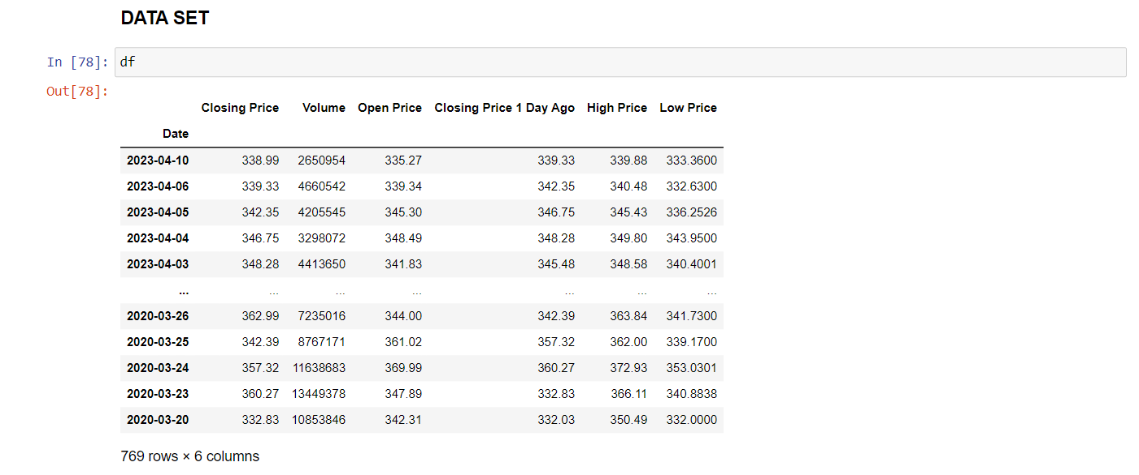

Netflix Company

Company Description:

Netflix is a global streaming service provider that offers a diverse selection of TV shows, movies, documentaries, and other content to millions of subscribers across more than 190 countries. Established in 1997, the company's streaming platform is accessible through various devices and features a mix of original and licensed content, with a primary emphasis on TV series and movies. Netflix has disrupted the entertainment industry with its innovative streaming model and has emerged as a household name. Its massive content library and continued investment in producing top-tier original content make it a dominant force in the streaming industry.

Overview:

Netflix has been enjoying financial success in recent years, with a YoY revenue growth of 24% to reach $25 billion in 2020, and a net income of $2.8 billion. The company's impressive financial performance can be attributed to its expansive global subscriber base, which surpassed 200 million in 2020, as well as its substantial investment in creating original content. Nevertheless, Netflix faces significant obstacles, including rising competition in the streaming industry and a substantial amount of debt. Given the dynamic streaming landscape, investors are likely to closely scrutinize Netflix's subscriber growth, content investment, and competitive positioning to gauge the company's long-term financial outlook.

Company Background:

Founded in 1997, Netflix started as a subscription-based DVD-by-mail rental service that provided customers with convenient access to a vast library of DVDs. As technology advanced, Netflix shifted its focus to streaming and launched its streaming service in 2007, offering customers on-demand access to an extensive range of content over the internet. Netflix continued to expand its content library and invested heavily in producing its original content, becoming a prominent global streaming service. Over time, Netflix has continued to evolve and innovate, introducing new features and interactive content to keep its subscribers engaged. Today, Netflix is a household name and a major player in the entertainment industry, boasting millions of subscribers worldwide.

Data Preprocessing:

Importing all necessary python libraries

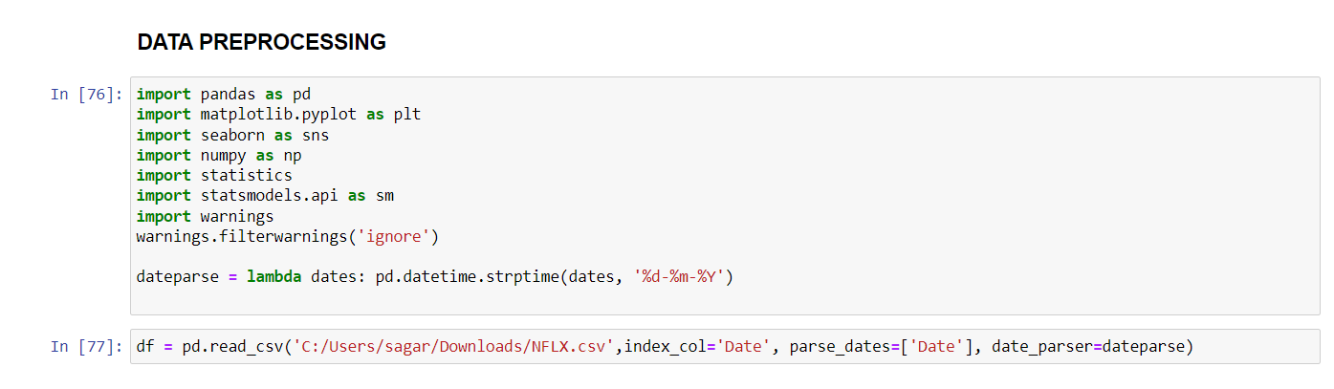



Data Visualization: Plotting graphs

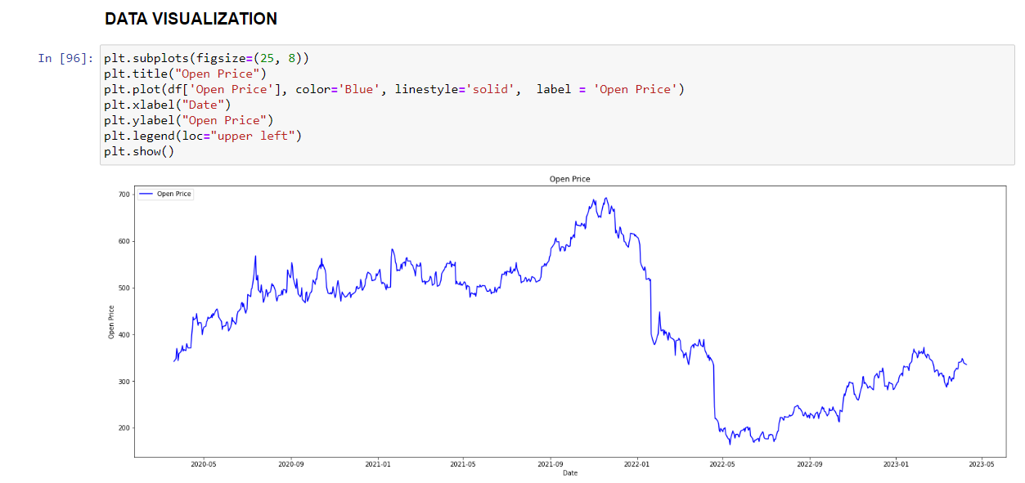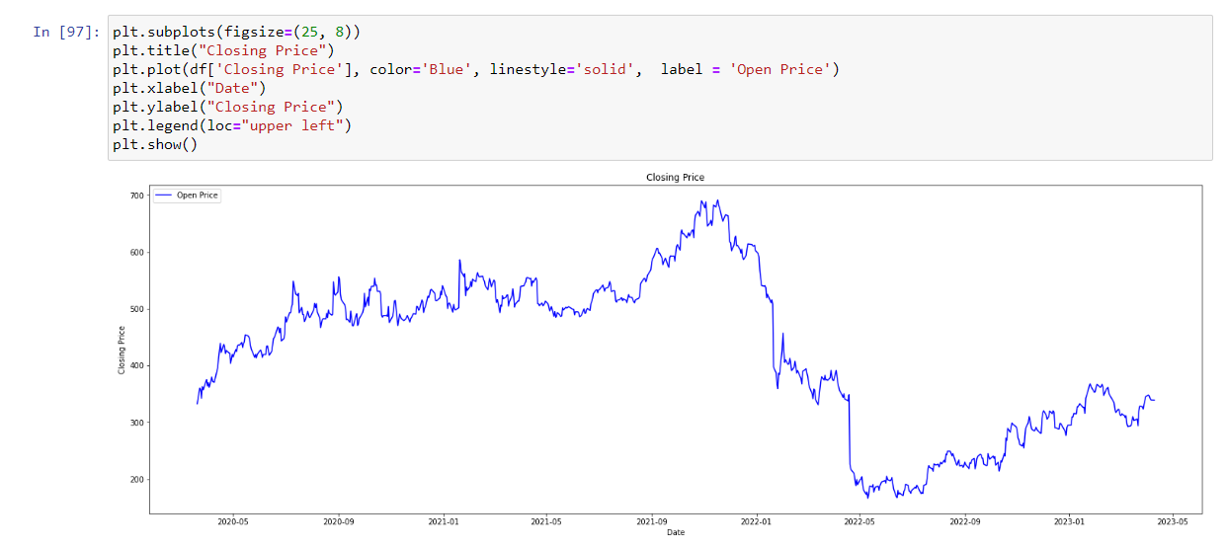

Comparison between Closing Price and Closing Price 1 Day ago

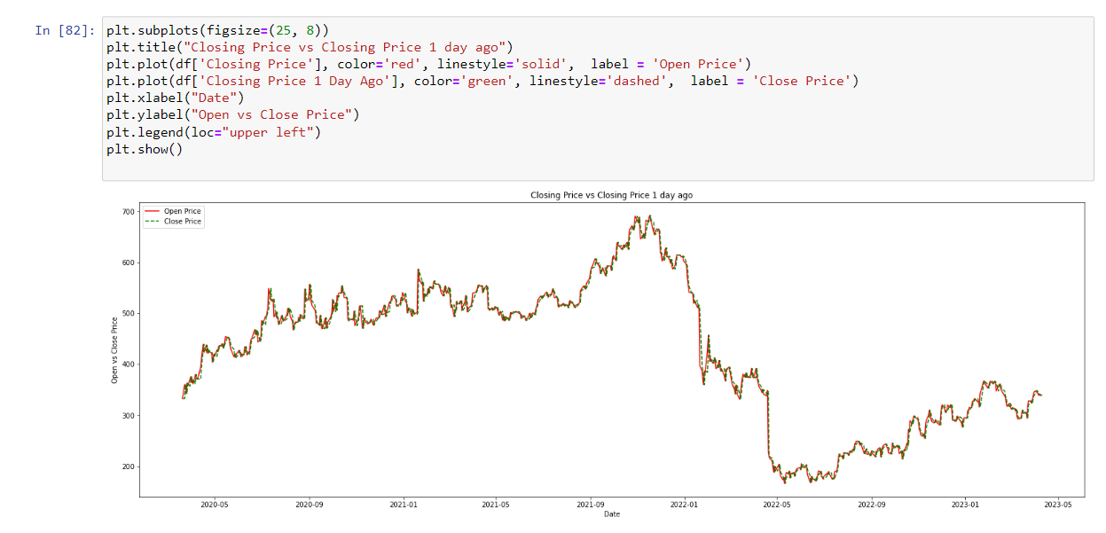

Comparison between Open Price and Closing Price

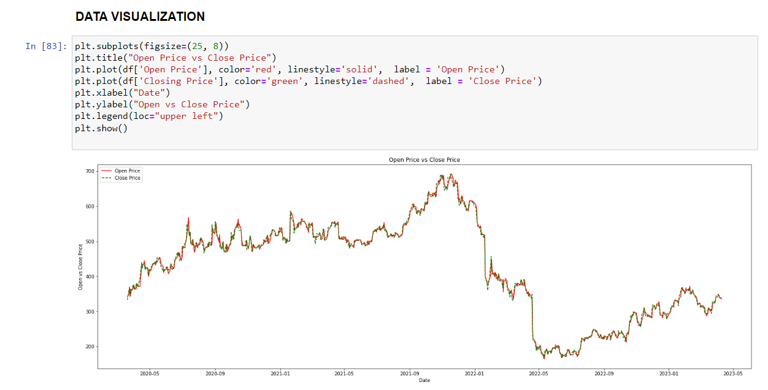

The plotted data suggests a general upward trend, along with some evidence of seasonality.

Stationarity:

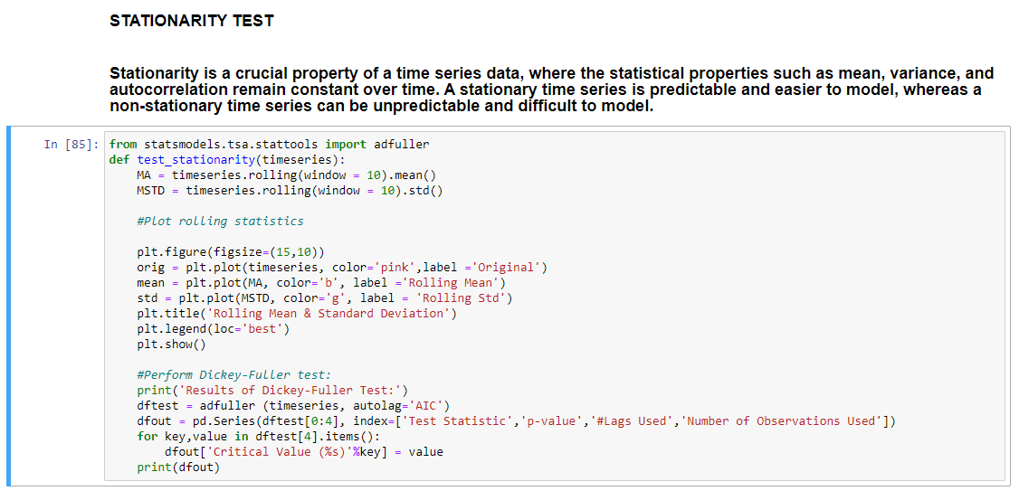

The Dickey-Fuller test is utilized in time series analysis to determine whether a time series is stationary or non-stationary. It does so by testing for the presence of a unit root in the data, which can indicate non-stationarity. The test involves comparing the test statistic to critical values from a specific distribution, and if the test statistic is less than the critical value, we reject the null hypothesis of non-stationarity and conclude that the time series is stationary.

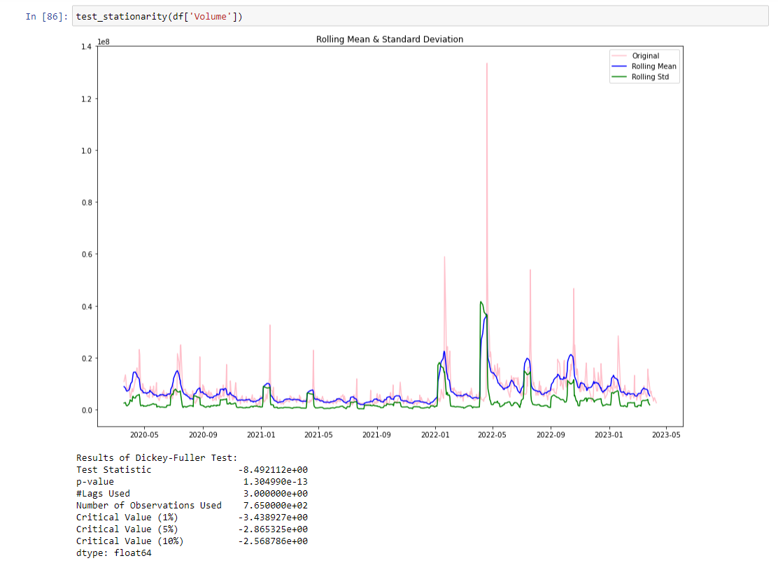

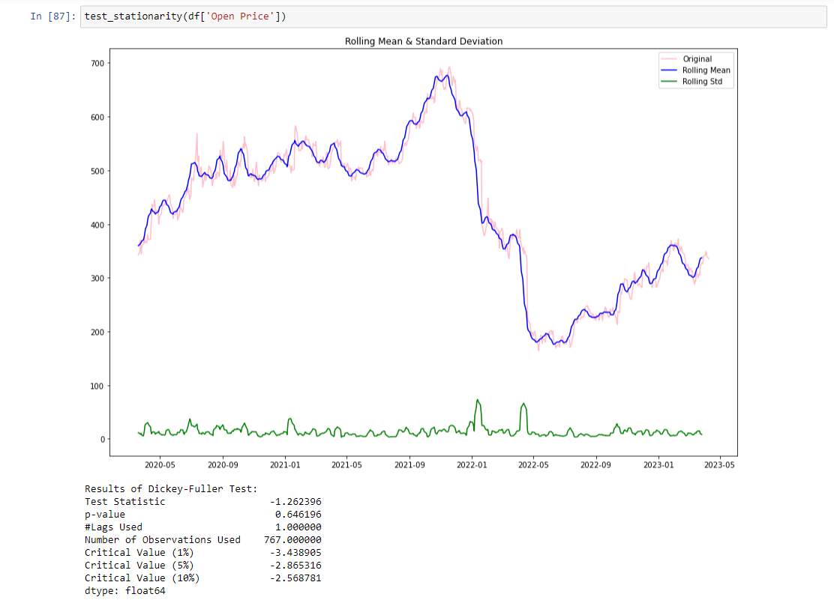

The graphs above do not show stationarity because:

* Mean is increasing even through the std is small
* Test stat is > critical value
* Note: the singed values are compared to the absolute values

Transformation:

There are two major factors that make a time series nonstationary they are

* Trend: non-constant mean
* Seasonality: Variation at specific timeframes

The first step is to reduce the trend using transformation, as we can see here that there is a strong positive trend. This transformation can be log, sqrt, cube root etc. Basically, it penalizes larger values more than the smaller. In this case we will use the logarithmic transformation.

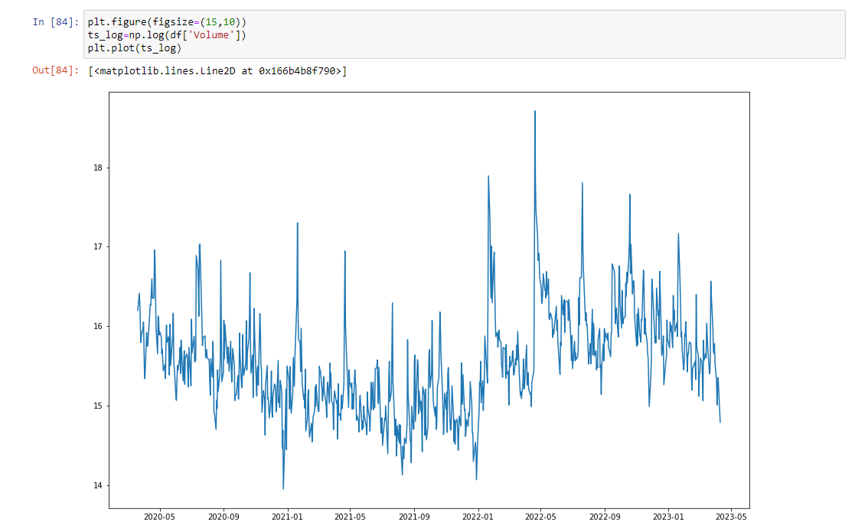

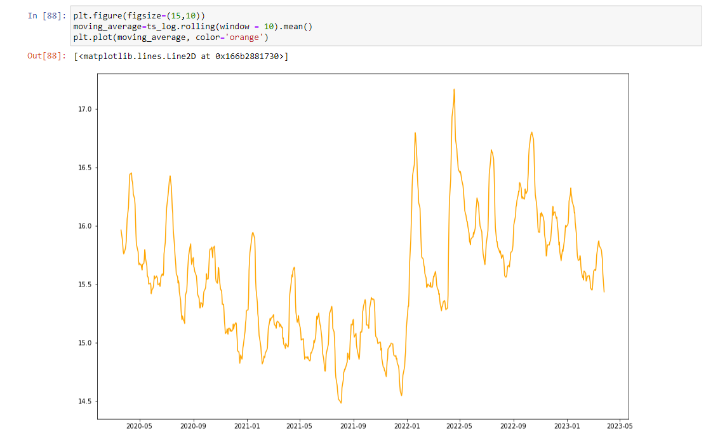

There appears to be some noise in the forward trend in this series. However, there are several methods available to model and subsequently remove trends from the time series data. Some commonly used techniques include:

* Smoothing: using rolling/moving average
* Aggression: by taking the mean for a certain time-period (year/month)

Smoothing of a time series may be useful in:

Applying a noise reduction technique can provide a more accurate representation of the underlying trend in a single time series. The resulting smoothed version of the series can be used as a feature to explain the original time series and provide better visualization of its underlying trend.

Seasonality (along with trend)

Earlier, we examined the trend component of the time series. Now, we will explore both trend and seasonality components as most time series exhibit both. There are two commonly used methods to remove both trend and seasonality, they are:

* Differencing: by taking difference using time lag
* Decomposition: model both trend and seasonality, then remove them

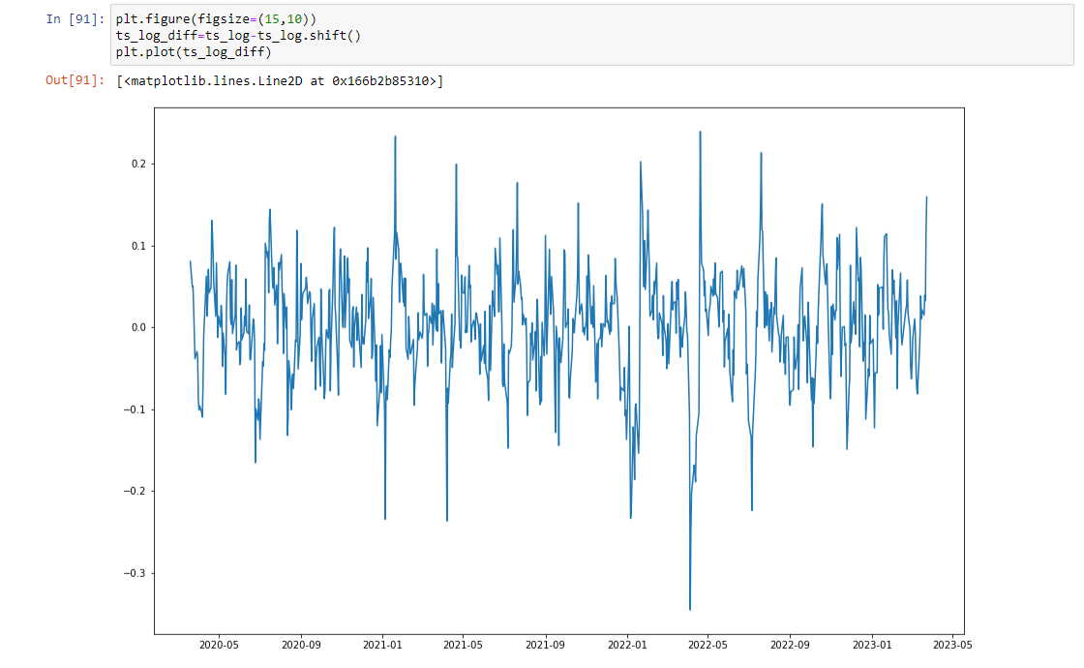

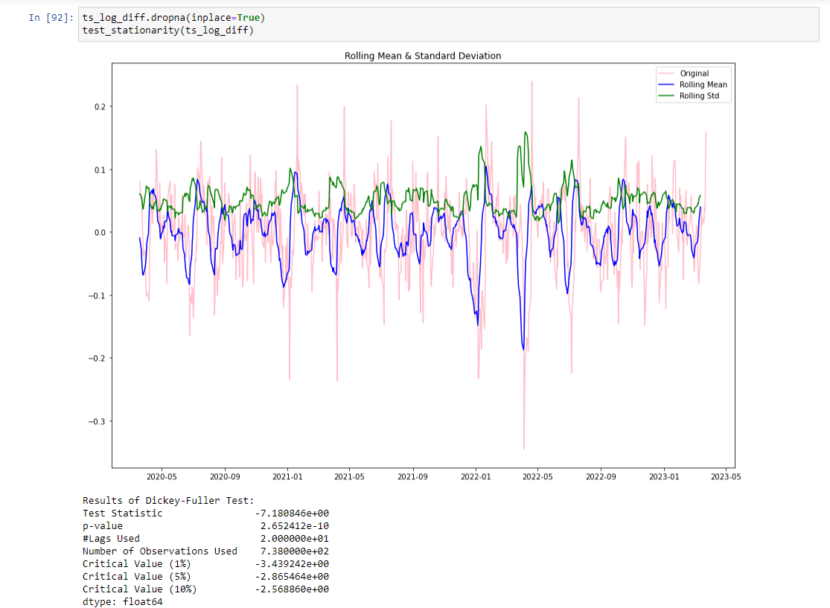

Modelling: Now let’s check out on how we can figure out what value of P&Q to use. We use two popular plotting techniques. They are:

* Autocorrelation function (ACF): between two consecutives. Lagged version. Example at lag 5. ACF will compare series at time instance. t1…t2 with series at instance t1-5…t2-5.
* Partial Autocorrelation function (PACF): is used to measure the degree of association between y(t) and y(t-p).

Autocorrelation Function (ACF)

Use the autocorrelation function (ACF) to identify which lags have significant correlations, understand the patterns and properties of the time series, and then use that information to model the time series data. From the ACF, you can assess the randomness and stationarity of a time series. You can also determine whether trends and seasonal patterns are present.

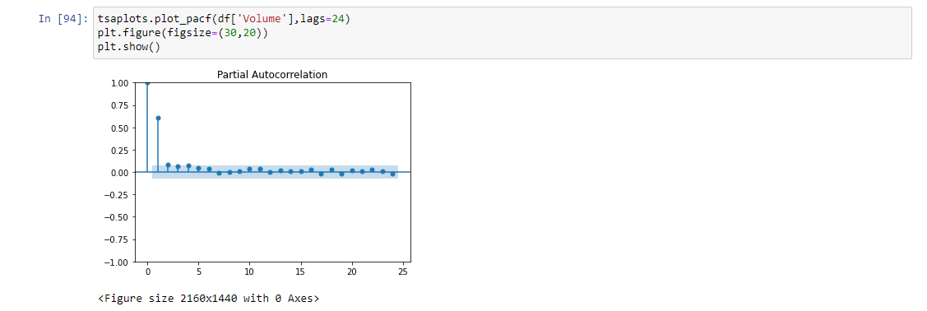

In an ACF plot, each bar represents the size and direction of the correlation. Bars that extend across the red line are statically significant.

Partial Autocorrelation Function (PACF)

The partial auto correlation function is similar to the ACF except that it displays only the correlation between two observations that the shorter lags between those observations do not explain. For example, the partial auto correlation for lag 3 is only the correlation that lags 1 and 2 do not explain. In other words, the partial correlation for each lag is the unique correlation between those two observations after partialling out the intervening correlations.

––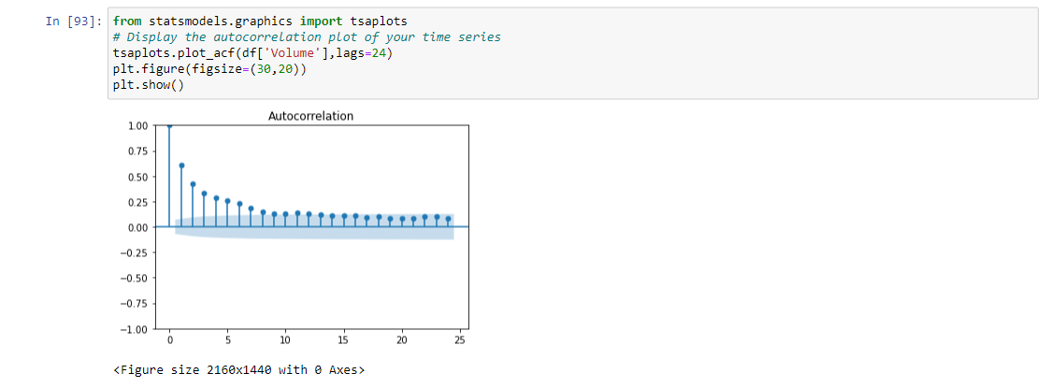

**ARIMA** Auto regressive integrated Moving Average (ARIMA) – it is like a linear regression equation where the predictors depend on parameters (p,d,q) of the ARIMA model.

Let’s explain these dependent parameters:

* p: This is the number of AR (Auto-Regressive) terms. Example – if p is the 3 the predictor for y(t) will be y(t-q), y(t-2), y(t-3).
* q: This is the number of MA (Moving Average) terms. Example – if p is the 3 the predictor for y(t) will be y(t-1), y(t-2), y(t-3).
* d: This is the number of differences or the number of non-seasonal differences.

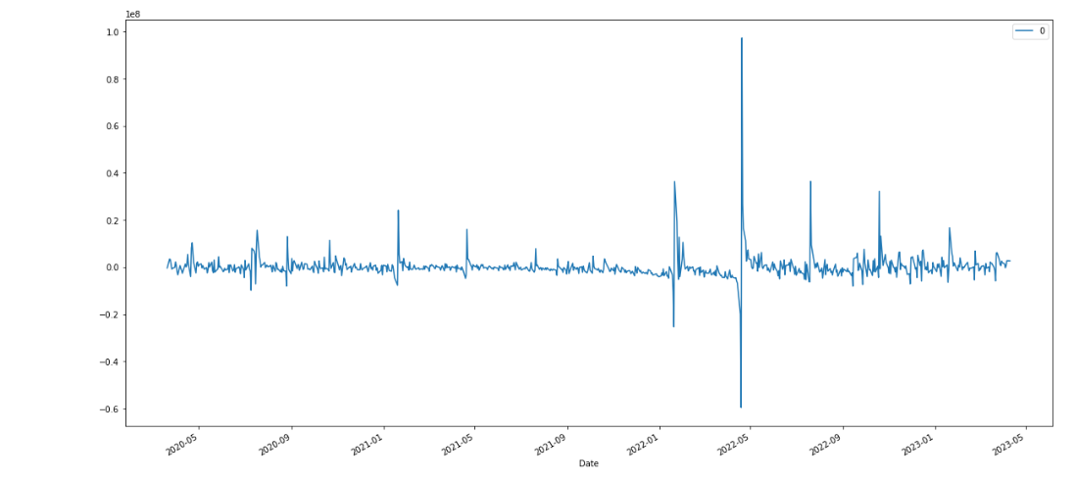

Conclusion: - Through the successful implementation of Time Series analysis on Netflix's stocks within a defined time interval, we gained meaningful insights into their performance. This analysis enabled us to obtain a deeper understanding of the market trends and dynamics, which in turn facilitated a more comprehensive evaluation of the Netflix stock.